Population Health Management, Unexplained Variations in Care, Improving QOF performance & income

Word document generated from the presentation at the Devon Digital Conference

# Conflict of Interest Statement

Prepared by Dr James Boorer

* Owner and software developer for Target Health Solutions Ltd. that creates population health management software and data driven recall systems.
* GP Partner at Pathfields Medical Group,
* Clinical director of Sentinel CiC

# Summary

1. There is huge unexplained and unacceptable variation in care across Devon and the UK
2. This variation is primarily due to practice processes and systems
3. We can do better for our patients with better health outcomes whilst also increasing our funding through QOF, LES and DES schemes
4. Practice managers, IT leads and admin teams are key members of the healthcare team that can save lives

# Avoidable deaths & ill health in Devon

Hypertension is a major driver of heart attacks and strokes. If we treated our known hypertensive population in Devon to target we could save huge numbers of lives. The following slide has icons to represent the 134 deaths, 249 strokes and 167 heart attacks that would be prevented over 3 years in Devon if we treated 80% of our hypertensive population to target.

When each icon represents a death or disabling illness this really hits home. Given the relative simplicity of treating hypertension to target you would assume that care should be relatively constant across all practices but we do not see this in the performance charts.

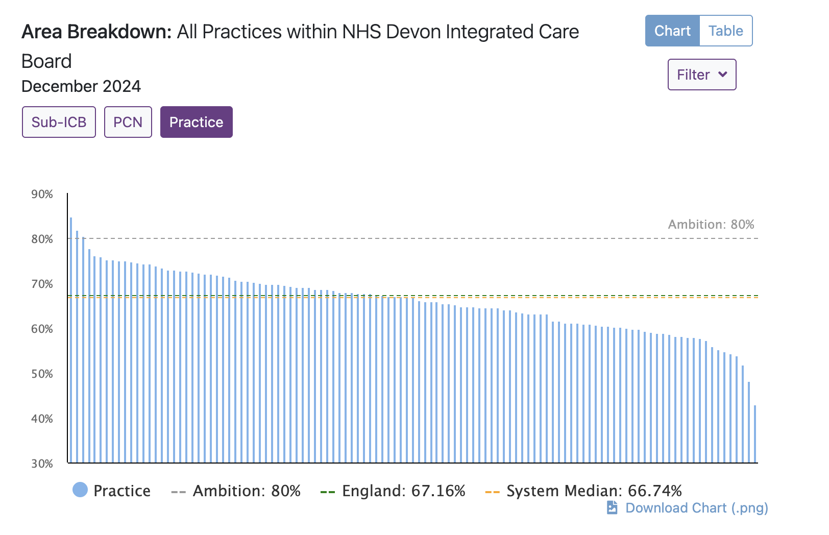

The ski slope chart from CVD prevent (nationally available open source data, prior to any exclusions / exemptions) shows that the best performing practice in Devon achieves 85% of hypertensive patients treated to target (Wembury – well done Dr Matt Waterman and team!). The worst performing “normal” practice only achieves 48% treatment to target – hugely different from Matt’s 85% achievement. [NB: the very worst performer is actually 42% but we should exclude this practice though as it treats a very specific and complex cohort in Exeter.]

## So the key question is why such variance?

Matt’s practice serves an affluent and older population but we would be wrong to assume this is the main driver of Wembury’s superb performance. If this was the case we would see affluence of patients strongly linked to hypertension performance and this is not the case.

If we look at our top performing practices in Devon the top 2 are certainly affluent but then we see St Levan surgery in 3rd spot serving a deprived community in Plymouth.

(Well done to all the practices at the top of this performance list!)

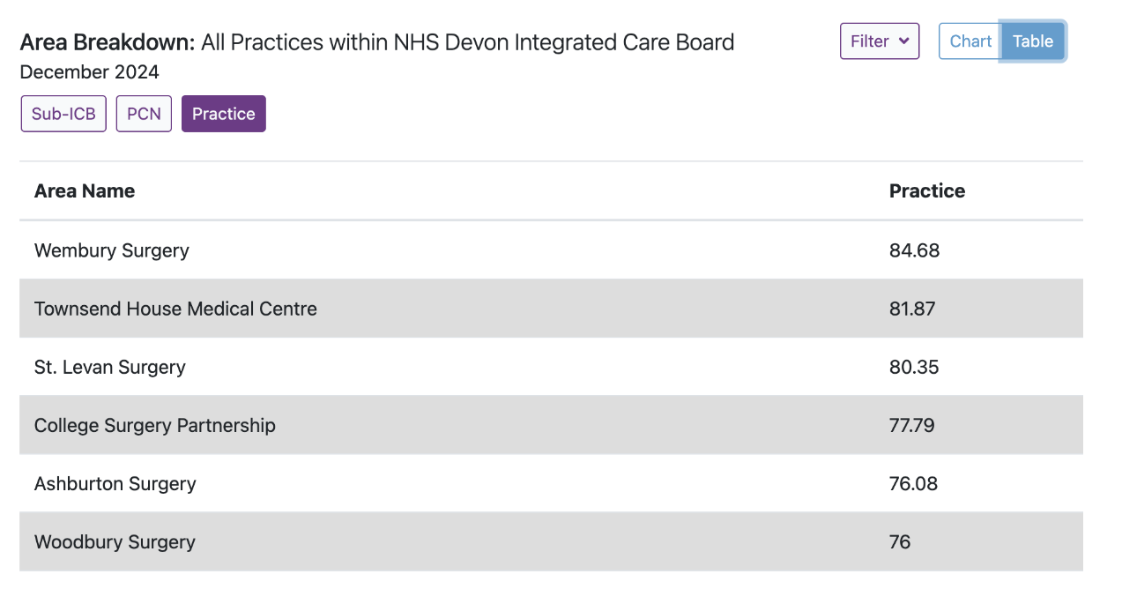

We can also look at the deprivation distribution of patients served by St Levan (below) and there is no doubt this is a practice doing a great job serving a deprived community. (deprivation data from the national diabetes audit).

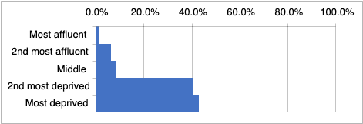

St Levan is not unique though. Many practices serving deprived populations do very well and although deprivation has an effect on performance the effect is relatively modest. The following chart from CVD prevent compares practices in the 5 deprivation quintiles and there is only 4% difference in performance between the most affluent and most deprived quintiles.

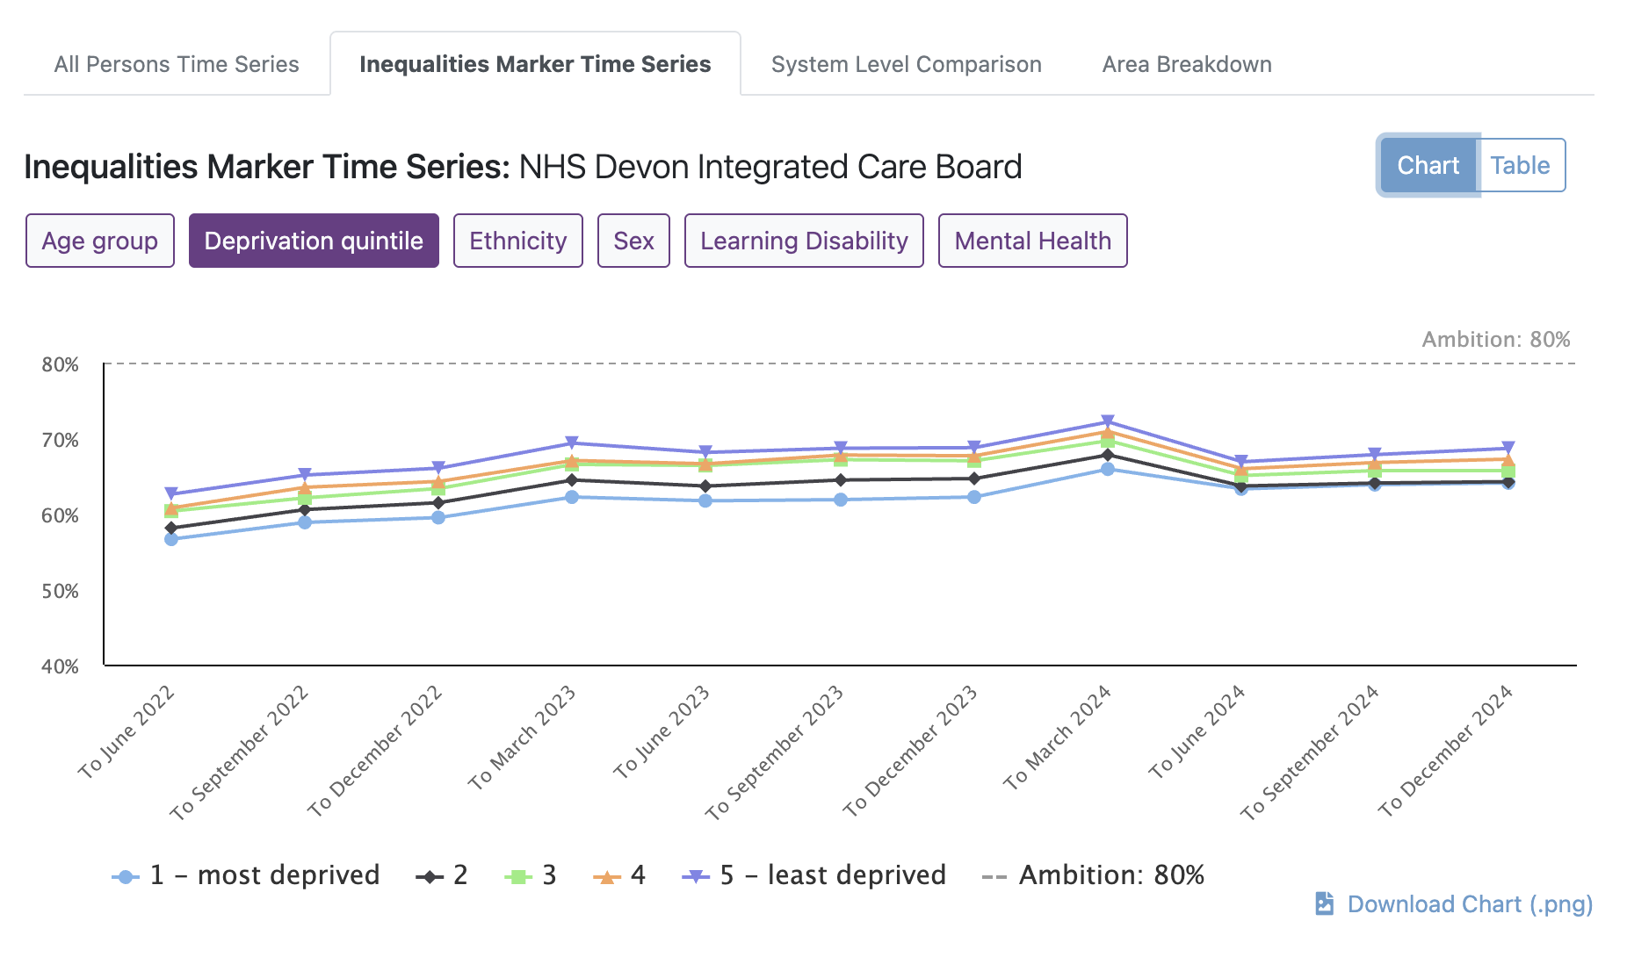

## Key message: Own your performance! No excuses! Save lives!

So one of the key messages is that it is essential that you own your performance and should not excuse poor performance by thinking your population is unique. We all have a variety of patients some that adhere well to treatment and some that don’t. If we optimise our systems and process we can all do better. When we do better we improve patient care, preventing those avoidable deaths, strokes and heart attacks. We also improve practice income.

# It is not just hypertension

We see huge unwarranted variation across every element of health care and especially long term conditions: Hypertension, Diabetes control; Lipid management; etc. Improving performance in all these conditions improves patient health and potentially practice finances.

# Understanding your data & how to improve performance

Our first recommendation is to get acquainted with your data so you know how you are performing. <https://www.cvdprevent.nhs.uk/> is a superb source of publicly available data on national performance.

Navigate to the above website and click insights, ICB, Devon:

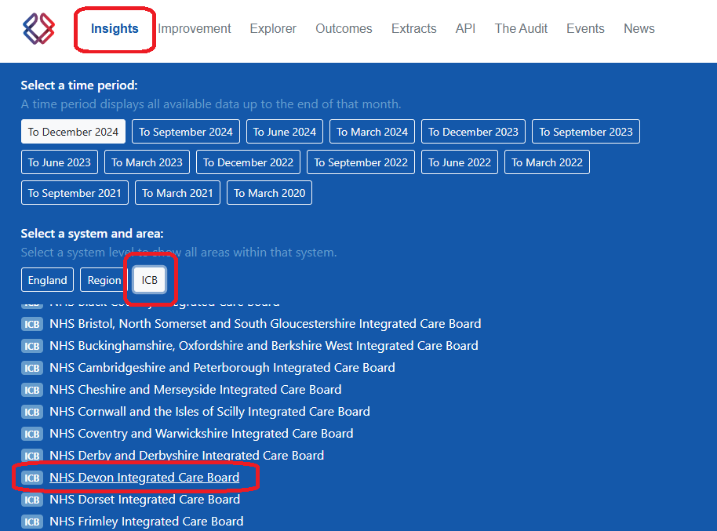

This opens up the CVD data for Devon – we will continue with hypertension as an example – click “open indicator” for CVDP007HYP:

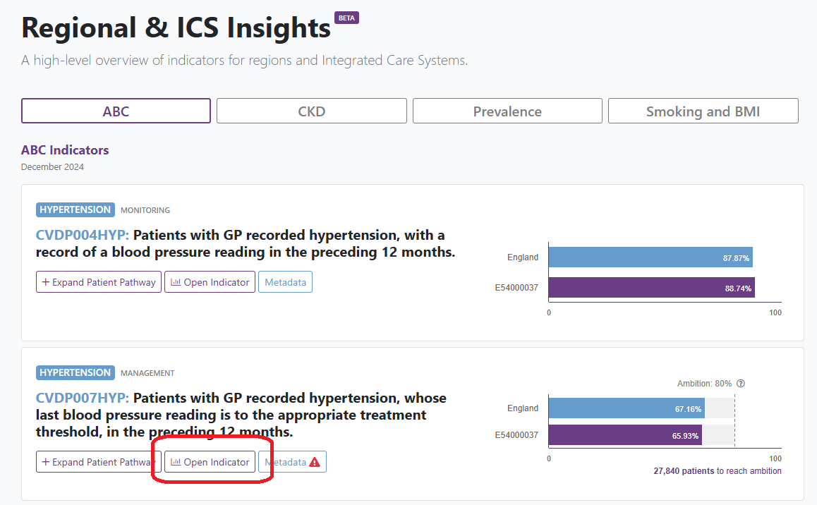

Now click on area breakdown, practice (or PCN if you prefer) – this provides you with the ski slope performance chart as below. If you prefer you can see the league table of performance by toggling table (red arrow).

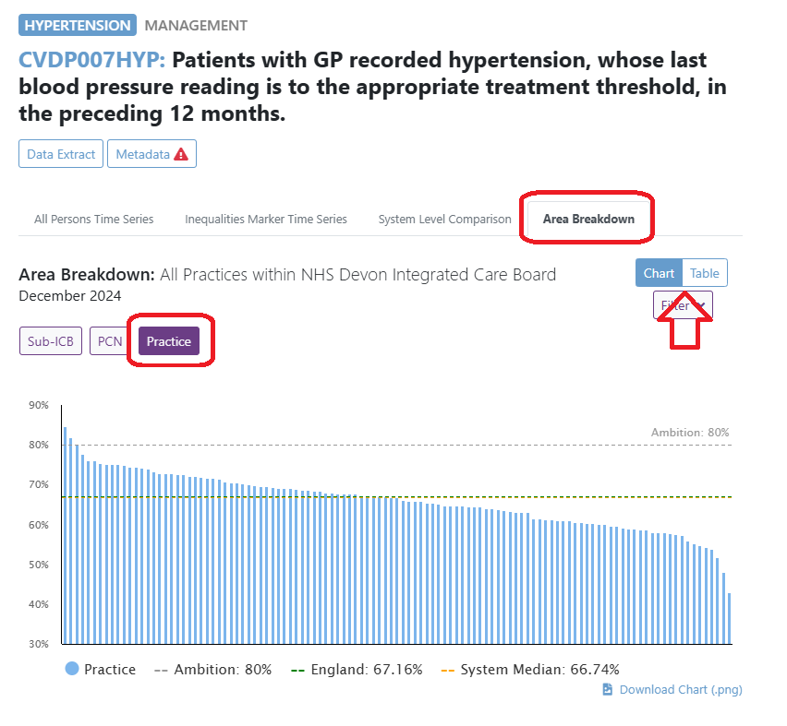

You can repeat this for other CVD quality markers – you can go back to the list of markers of navigate through them using the arrows (see below).

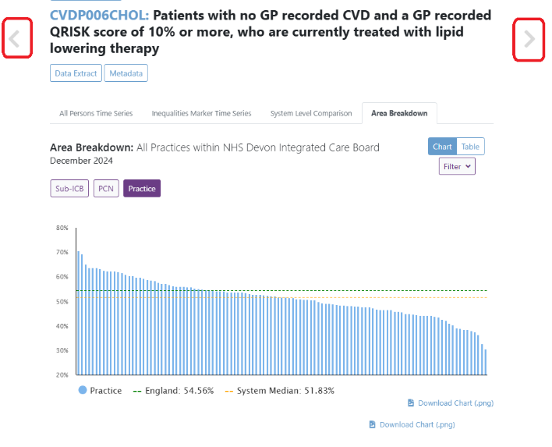

# Focusing on improvement

To improve it is useful to think about process and here we can draw on the work of Prof Chris Bentley who talks of implementation decay.

There is a process to follow:

1. Identify those with the health problem
2. Make them aware of the problem
3. Determine eligibility for treatment (very few reasons not to treat but these include frailty / EOL care)
4. Offer patients optimal treatment
5. Encourage patients to adhere to optimal treatment

At each step on this pathway there is scope to fail, resulting in reduced performance, unmet health care need and avoidable deaths, strokes and heart attacks. Let’s work through these issues again using hypertension as an example. We can probably simplify Prof Bentleys model quite a bit

1. Diagnosing /identifying the health problem
2. Treating the health problem to target

## 1: Identify those with the health problem

Public Health England believe that over 1 in 4 adults have hypertension but for every 10 people diagnosed with hypertension another 7 go undiagnosed and untreated: <https://www.gov.uk/government/publications/health-matters-combating-high-blood-pressure/health-matters-combating-high-blood-pressure>.

Your practice data will support this PHE statement. The following data comes from Pathfields Medical Group and is extracted using THS software (note the conflict of interest). Pathfields serve a relatively deprived population in Plymouth and currently have nearly 30,000 patients.

The following chart shows the % of our adult population with diagnosed hypertension (blue) and people with a high blood pressure on last check without a hypertension diagnosis (yellow). The changes to our population are shown over time on the x axis and you will note a step change in January 25 where we merged 2 practices together, with the joining practice having a younger population and thus lower levels of hypertension.

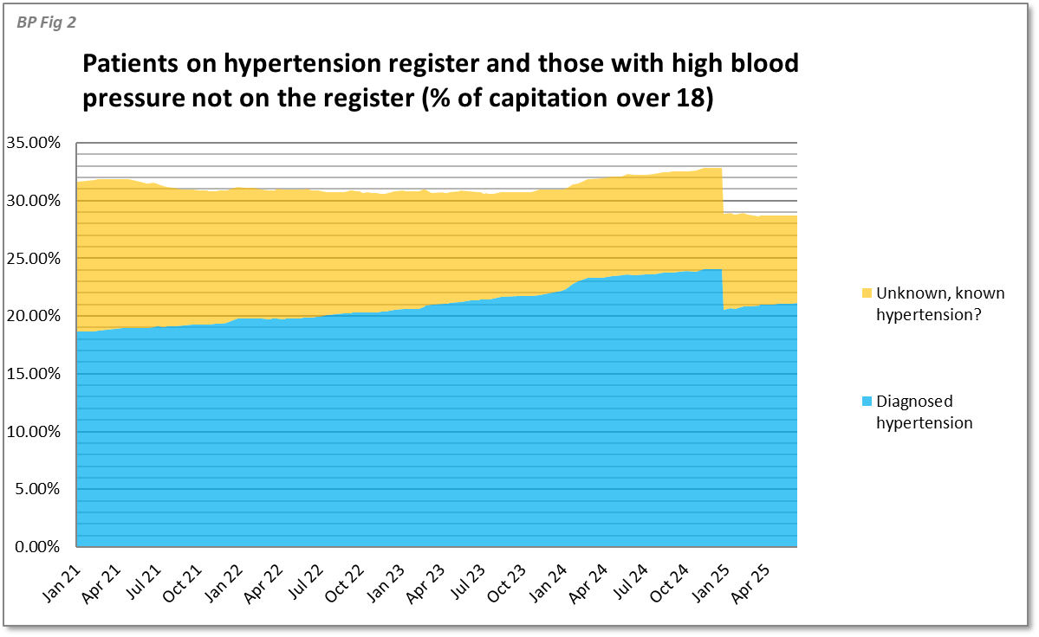

What we see is that PHE is right! About 7 in every 10 hypertensive patients go undiagnosed. We might assume that actually many of those with high blood pressure on the last check without a hypertension diagnosis are in this group due to a one off high BP that we can ignore but this is not the case as we can see we have steadily converted many of these undiagnosed hypertensive patients into known hypertension over a period of a few years (blue zone increasing, yellow zone decreasing).

We can look at PHM data another way – by age group (y axis in the following chart) and we can see that hypertension prevalence is strongly linked to age and our undiagnosed hypertensive patients are primarily in the 40-60 age group (the few years before their first heart attack or stroke?).

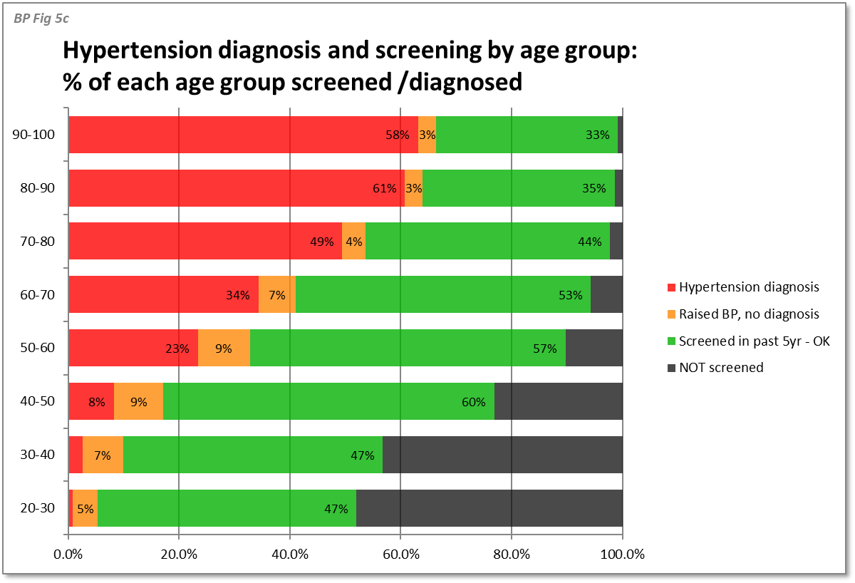

You would hope that the undiagnosed hypertensive patients only had a slightly high BP but this hope is not justified: Of the 13% of our adult capitation with undiagnosed hypertension, most have stage 1 hypertension but about 1.5% of all adults have undiagnosed stage 2 or worse hypertension and are at even greater risk of adverse health outcomes.

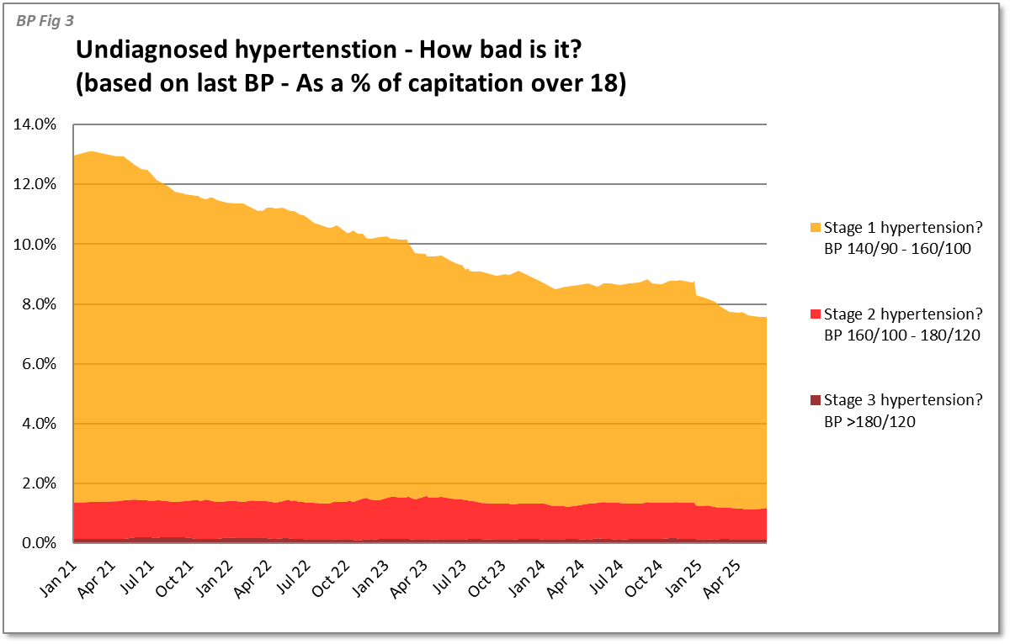

Interestingly, as a practice, we have managed to reduce those with stage 1 hypertension over time by proactively contacting these patients and asking them to attend their community pharmacy for hypertension checks or using the machine in our waiting area. The same offer has been extended to our patients with undiagnosed stage 2 and 3 hypertension but these numbers have not fallen at the same rate – maybe this is a hard to reach / non compliant population? Maybe we need to offer different approaches to their care?

It is great that we have reduced our undiagnosed hypertension from 13% to 7.5% but that still leaves many patients undiagnosed. Could we do more? Absolutely! But additional work requires more funding and hypertension work simply does not pay well enough so we must balance patient benefit, financial incentives and costs in delivery of care. If we work out the income per patient from QOF (it is not easy to do this, possibly deliberately?!) we see that each hypertensive patient treated to target boosts practice income by about £7 per patient. £7 is not much given that these patients need annual monitoring and possible medication adjustments (a few years ago NICE modelled costs of hypertension care in GP surgeries of £125 in year 1 and £75 per year thereafter – I believe we can do it far cheaper than this but we can’t get anywhere near £7).

We therefore have the first and greatest population health performance loss as per Prof Bently’s implementation decay model. Diagnosing additional hypertensive patients is in essence pro-bono work – its important and impactful for patients but it does not cover costs. We therefore need to pick a really efficient model for diagnosing and treating this cohort – hence the reason to leverage community pharmacies and machines in our waiting rooms and using pharmacy tech to lead on hypertension medication management.

## 2: Treatment to target

This simplification of Prof Bently’s implementation decay model covers eligibility for treatment, provision of treatment and adherence to treatment – we need all 3 to hit our performance targets.

The QOF funding for treatment to target is limited – you are funded at about £7 for every hypertensive patient on your practice register, if you have not excluded them, and if you hit your upper QOF threshold. Another way of looking at this is for every patient treated to target between QOF thresholds you receive funding worth about £15.50. You will be very aware that this QOF funding will not cover the costs of delivering care. Our commissioners argue that the bulk of hypertension funding is part of our core contract – I’m not sure I agree with our commissioners!

However, before we bemoan the lack of funding we must factor in that most practices are already doing most of the work for monitoring and treating hypertension, but our poorly performing practices are doing this work inefficiently and ineffectively. From looking at individual cases I believe the issues are as follows:

1. Patients do not respond to recall and thus get excluded after 2 invites
2. When patients are seen we don’t always do all QOF relevant tests and metrics in one sitting
3. Where we do record a blood pressure above target we frequently fail to act appropriately on this:
   1. We might ignore blood pressures that are only slightly above threshold
   2. We might collude with patients that a little more diet and exercise (that in most cases we know won’t happen) will bring their blood pressure down
   3. We fail to follow up treatment interventions (either diet and exercise or new medication) with further BP checks

### Recall & Responding to recall

Month of birth recall is used by many but it is ineffective when people have conditions that need more frequent monitoring (eg: diabetes) or where people have metrics that are not to target – follow up needs to be set manually in these cases and we all know that clinicians are rubbish at remembering to set recalls!

Traditionally practices have exempted patients from QOF if they have been recalled twice and failed to respond. This does make your QOF targets easier to achieve but overall you loose income because your prevalence factor in QOF is less (you loose £7 per patient who is excluded from QOF for hypertension). This approach also fails to wash with CQC – if you fail to monitor U&E in people on ramipril for hypertension and claim you offered recall but the patients ignored you CQC will still haul you over the coals – in such circumstances you either need to stop the medication (there are risks to this) or have a case by case review about the risk / benefit of continuing a medication without monitoring tests. In general we think it is easier to keep badgering patients until they get their recalls done for both medication safety and to check treated to target.

### When patients are seen not all QOF relevant tests are done (or may be done again when not required)

This is a huge issue for efficiency. Knowing what tests a patient requires when they have multiple conditions and medicines requiring variable monitoring is really tricky. Expecting your HCAs and nurses to get this right is unrealistic as often doctors get this wrong. Various software systems exist to support this process. You should look for a software system that prompts for all relevant tests and one that does not repeat tests when not required. (Note my conflict of interest in this regard with Target Health Solutions).

### Failure to act on abnormal results

#### a) Thresholds are not targets!

I believe we (docs and nurses) get into the habit of thinking that the upper target limit, like a blood pressure of 140/90, is normal. 140/90 is NOT normal! A normal BP is 120/80. 120/80 is our target BP but the science says we should accept blood pressures up to 140/90 as being above target but reasonable, with limited benefit from additional medication. Above 140/90 we have an issue and we need to be pushing additional medication.

Medical nerd alert:

For the true medical nerds who read NICE efficiency documents (like me) the reality is more complex and if young people under 40 have stage 1 hypertension the cost effectiveness argument can’t be made for treating them with medication: They don’t derive enough benefit within 10 years for hypertension management to be cost saving to the system. BUT arguably they are storing up vascular damage that will result in avoidable strokes and heart attacks > 10 years down the line. There is debate in the medical community about treating hypertension in younger adults and the science is lacking. NICE recommends diet and exercise and review (each review costs money!). QOF metrics don’t however take any account of this and are much more simple. Highly nuanced and individualised care is expensive to deliver and will loose you money. If I had high blood pressure in my 30s I think I’d want treatment for long term benefit - so lets keep it simple and treat everyone with meds if their BP is > 140/90 and diet and exercise has been ineffective / not likely to happen.

#### b) Collusion with patients about diet and exercise

This is closely linked to miss-interpreting thresholds: A normal BP is 120/80 and when between 120/80 and 140/90 we need to be pushing diet and exercise. Above 140/90 we probably need to be more medication focused – giving patients one shot at diet and exercise over a few months is not unreasonable but most fail to make the drastic lifestyles changes required and too often we see patients coming back with a BP or HbA1C above target and clinicians colluding with them that a little more diet and exercise will help even thought hey have failed to gain control with this approach for 3+ years! If the metric is above target add meds unless you truly believe the patient is willing and able to make drastic life style change.

#### c) Failure to follow up post intervention

With the month of birth recall system we often fail to follow up or arranging follow up is manual, time consuming and expensive. Thus we might see a patient with a BP of 150 /90 and they want to try diet and exercise which is potentially reasonable but we often fail to chase a repeat BP to see if diet and exercise has been effective. They may not get a repeat BP until their birth month next year where we find the patient did not really engage with diet and exercise and their BP is now worse than it was the previous year. During this time we have wasted an opportunity to intervene and improve the patient’s health and we have done the basic monitoring but because we failed to achieve target we have no financial funding to support this basic work.

### Treatment to target summary:

Have a data driven approach to recall – recall those without a BP to target in 1 year or those who’s last BP was above target and a few months ago. When people come in treat high BPs with suitable respect and add medication unless there is a good reason not to.

Operationalising this approach is difficult and time consuming without software that uses data to drive recall – pick a recall system that is data driven to drive those performance improvements, improve efficiency and maximise income.

# Summary

* Population health management is key to improving the heath of our patients and reducing avoidable ill health, admissions and need for social care.
* PHM work is underfunded and we need to work on this with ICB colleagues to develop QOF+ incentive schemes that fund great care appropriately
* Practices can changes systems and processes to increase efficiency (minimising cost) whilst also improving performance and increasing income.

See also

1. Check out your performance on CVD prevent
2. Check your diabetes performance in the NDA dataset that we have shared with the LDC team (enter your practice L code to get your data)
3. Use the QOF exemption calculator in March of next year to work out how many people you need to exempt to earn the most money (you want to achieve maximum treatment to target without exempting more people than you need)

I’m very happy to chat all things PHM as I’m passionate about it! Email: [james.boorer@nhs.net](mailto:james.boorer@nhs.net) or phone 07866 482 545. If I don’t respond to an email within 2 days assume it has become buried in my inbox of doom and chase me!