**Devon New to Practice Fellowship**

This document provides an overview of the Devon New to Practice Fellowship. It includes an outline of key elements as well as a timeline indicating the slightly different pathways followed by GPs and GPNs. The subsequent pages cover the following:

Overview of Programme Elements

NTPF Timeline for 2 years from Cohort 2B start date October 2022

[more details of exact dates are available if required]

Career and Education Pipeline for New to GP Nurses

[with Year 2 added]

Descriptors of Special Interests Groups

Framework for Nursing Practice Interest Groups

Partnership Preparation Programme

Next Generation GP

**Email** [**shs.dth.fellowshipadmin@nhs.net**](mailto:shs.dth.fellowshipadmin@nhs.net) **for more information**

**Devon New to Practice Fellowship (overview)**

**New to Practice Timeline from October 22** (starting with Cohort 2B) **for two years**

|  |  |  |  |  |  |  |  |  |  |  |  |  |
| --- | --- | --- | --- | --- | --- | --- | --- | --- | --- | --- | --- | --- |
| **Year One** | **Oct 22**  Cohort 2B start | **Nov 22** | **Dec 22** | **Jan 23** | **Feb 23** | **March 23** | **April 23**  Cohort 3A start/1A finish | **May 23** | **June 23** | **July 23** | **Aug 23** | **Sept 23** |
| **ALL NTPF**  (Timetabled) | Join NTPF Cohort, 1-2-1, induction & 1st WFM | Complete/  Ongoing | | | | | WFM  &  Celebration Event | ALS | SIG | ALS  WFM  (with local groupwork) | NTPF events paused over summer | SIG  ALS |
| **ALL NTPF**  (Self-Directed) | Mentoring & Coaching  1-2-1s  Shadowing and Project Work | | | | | | | | | | | |
| **GPs** | NTPF  Full  Programme | Complete/  Ongoing | | | | NGGP  (optional) | NGGP  (optional) | NGGP  PPP  (optional) | NGGP  PPP  (optional) | NGGP  (optional) |  | PPP  (optional) |
| **GPNs**  (UoP route) | UoP  Fundamentals  (Sept start) | Complete/  Ongoing | | | |  |  |  | UoP nearing completion | Cervical Sample Taking |  |  |
| **GPNs**  (non UoP route) | DTH  Skills Package  TtPC | Complete/  Ongoing | | | |  |  |  | DTH nearing  Completion | Cervical Sample Taking |  |  |
|  |  |  | | | |  |  |  |  |  |  |  |
| **Year Two** | **Oct 23**  Cohort 3B start/1B finish | **Nov 23** | **Dec 23** | **Jan 24** | **Feb 24** | **March 24** | **April 24**  Cohort 4A start/2A finish | **May 24** | **June 24** | **July 24** | **Aug 24** | **Sept 24** |
| **ALL NTPF**  (Timetabled) | WFM  &  Celebration Event | ALS | SIG | ALS  WFM  (with local groupwork) | SIG | ALS | WFM  &  Celebration Event | ALS | SIG | ALS  WFM | NTPF events paused over summer | SIG  ALS |
| **ALL NTPF**  (Self-Directed) | Mentoring & Coaching  1-2-1s  Shadowing & Project Work | | | | | | | | | | | |
| **GPs** |  | PPP  (optional) |  |  |  |  |  |  |  |  |  |  |
| **GPNs**  (UoP route) |  | NPIG | NPIG |  | NPIG | NPIG | WFM  &  Celebration Event | NPIG | NPIG |  |  |  |
| **GPNs**  (non UoP route) |  | NPIG | NPIG |  | NPIG | NPIG |  | NPIG | NPIG |  |  |  |

[Dates TBC: QI, Continuity of Care, as well as PPP, NGGP for year 2]

**KEY:**

WFM = Whole Fellowship Meet (8hrs) ALS = Action Learning Set (3hrs)

SIG = Special Interest Group (2hrs) NPIG = Nursing Practice Interest Group (6 hrs)

PPP =Partnership Preparation Programme UoP = University of Plymouth

TtPC = Transition to Primary Care DTH= Devon Training Hub

**NB: Cohort 2B will culminate at the October 2024 WFM with a celebration event,**

**including oral presentations or poster presentations reflecting projects or NTPF learning.**

**Career and Education Pipeline for New to GP Nurses**

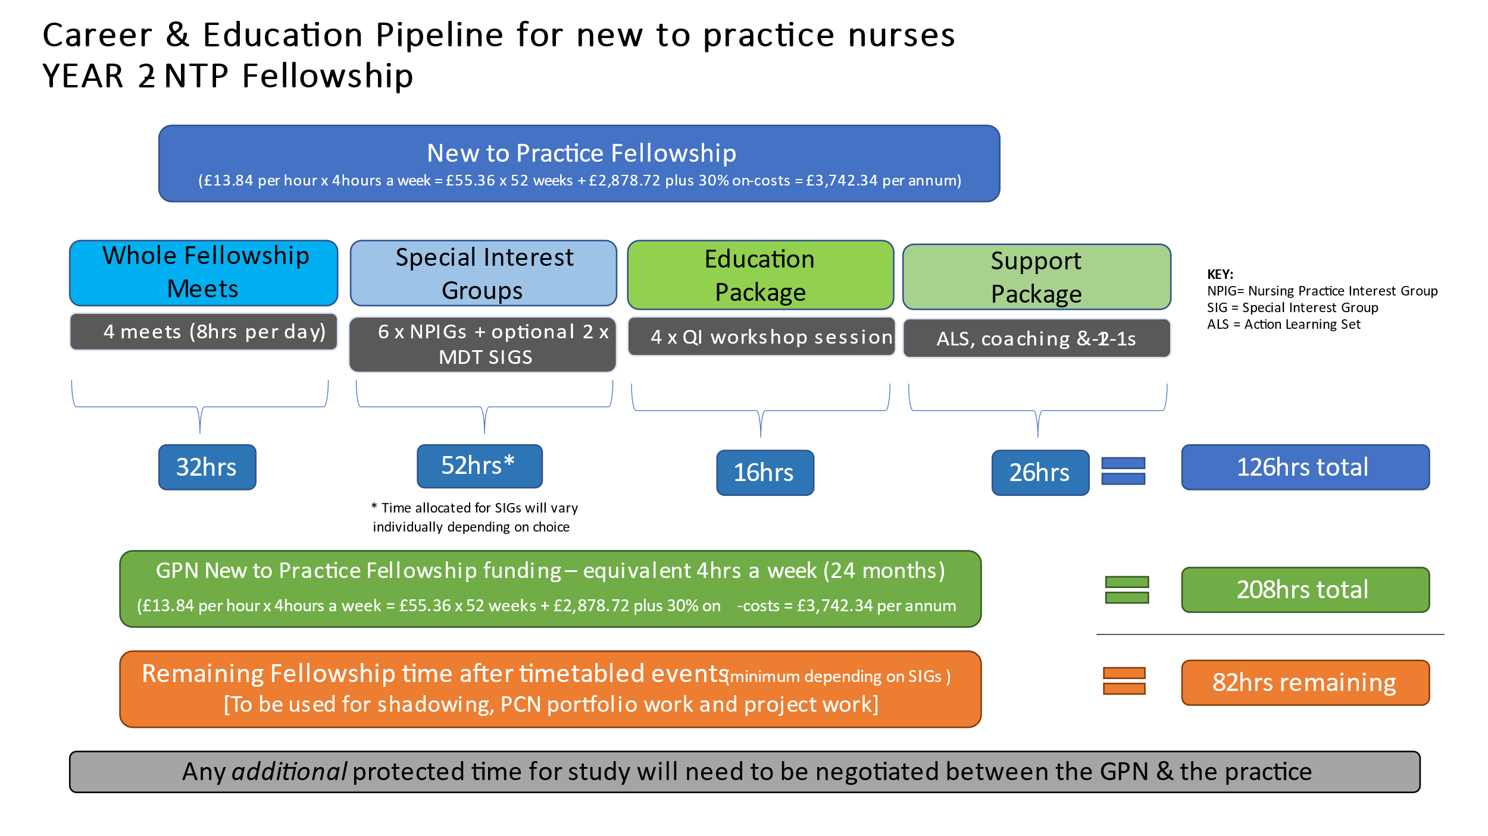

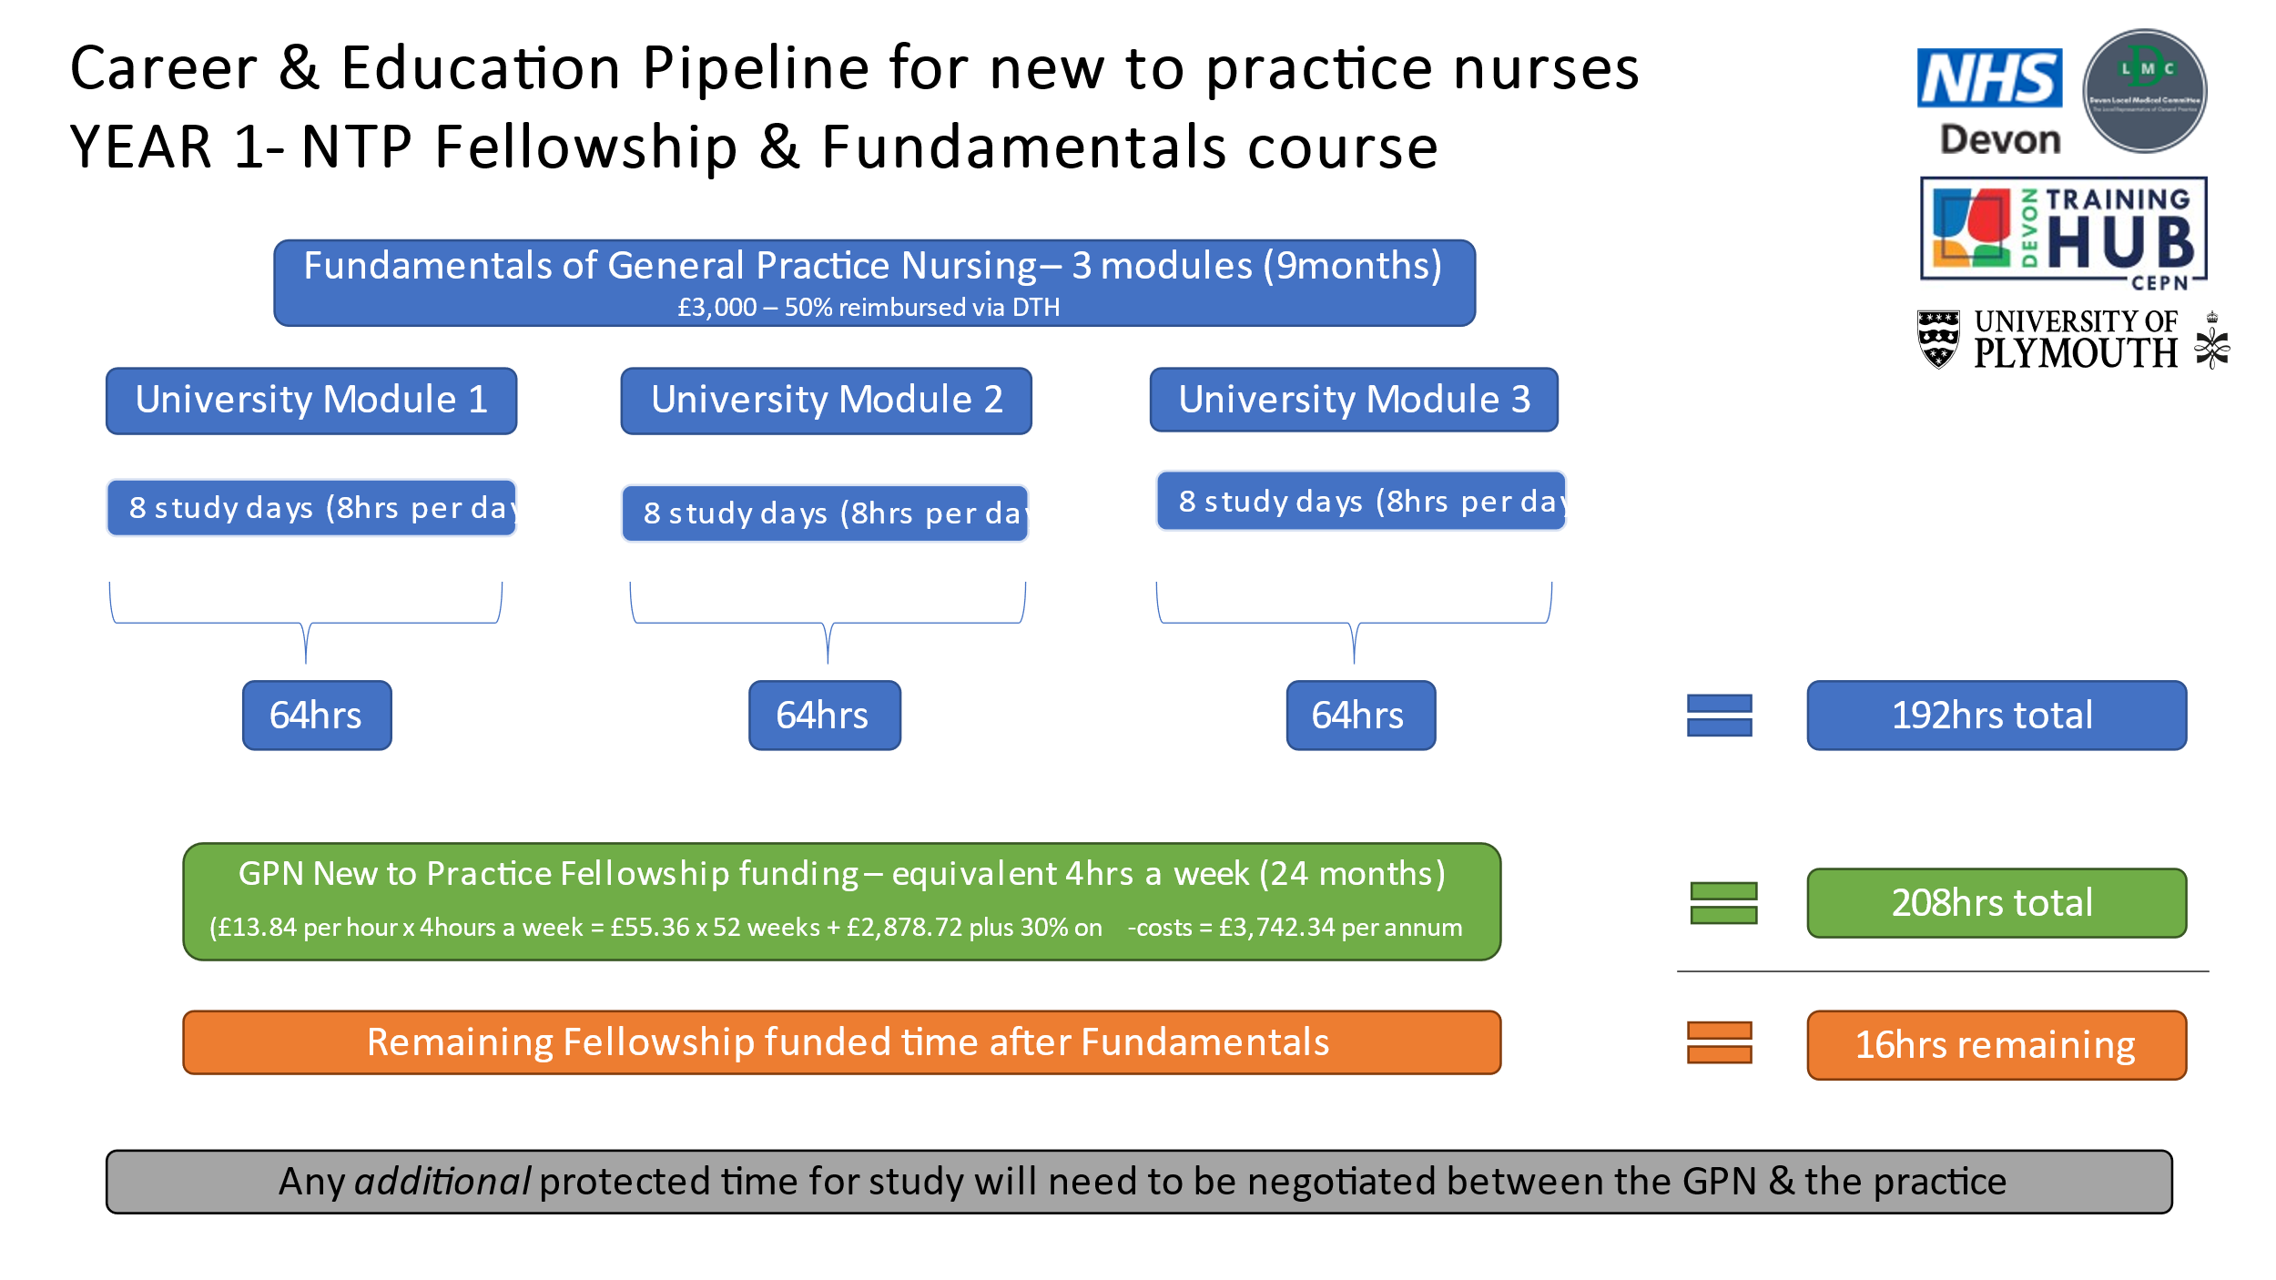

**Special Interest Groups**

**Nursing Practice Interest Groups**

These groups are aimed at building on knowledge gained in Year One, either through the HEI Fundamentals Programme (UoP) or through TtPC and Skills Package (DTH). They will alternate between F-2-F and online workshops. Each session will focus on one key area but work through different elements to build on complexity whilst allowing them to be accessible to all nurses on the programme at any stage. There will be six in total.

**NB:** Nurses are also able to join the SIGs if relevant and useful for their practice. This may also be dependent on their NTPF 2nd year focus.

**Partnership Preparation Programme**

* 10 part webinar series of sessions lasting 60-90 minutes from 1300-1430 on Wednesday lunchtimes
* 15 mins delivery at start followed by facilitated small groups then coming together at the end

**Module 1: Partnership Finances**

|  |  |
| --- | --- |
|  | **Proposed date** |
| 1A: Understanding balance and income statements | 10/5/23 |
| 1B: Understanding the key financial ratios | 24/5/23 |
| 1C: Generating revenue | 14/6/23 |
| 1D: Partnership liability | 21/6/23 |

**Module 2: Key Legal Frameworks and Contracts**

|  |  |
| --- | --- |
|  | **Proposed date** |
| 2A: Understanding partnership agreements | 6/9/23 |
| 2B: Understanding GP-NHS contracts | 13/9/23 |
| 2C: Introduction to employment law | 27/9/23 |

**Module 3: Communication Strategies and Skills for Partnership**

|  |  |
| --- | --- |
|  | **Proposed date** |
| 3A: Getting the most out of partnership meetings (influencing and negotiating) | 1/11/23 |
| 3B: Dealing with difficult situations (handling conflict, dealing with staff) | 15/11/23 |
| 3C: Interview skills | 22/11/23 |

**Next Generation GP**

‘Next Generation GP’ is a programme for **emerging leaders** **in general practice** designed by, and for, a group of early-career GPs and trainees.

Our aim is to inspire early career GPs (trainees and first 7 years post CCT) to be informed leaders as well as excellent clinicians, with the insight and connections they need to change and improve the system in which we work. We are excited to now be bringing a new programme to the South West after the first successful programme was run in 2019 and after a COVID-related break a second cohort was run face to face in 2022.

This year all sessions will be run face to face at Buckfast Abbey on weekday evenings.

|  |  |
| --- | --- |
| Tuesday 7th March | **Robert Varnam - former National Director for General Practice Development**  Lead with Why: How to get started with a leadership idea |
| Thursday 20th April | **Dr Khajdija Owusu – TEDx speaker, Director of Melanin Medics, Junior Doctor** |
| Tuesday 23rd May | **Will Duffin – Joint Medical Director for World Extreme Medicine, NB Medical Presenter, Locum & Urgent Care GP**  Personal Leadership: Tools to Make an Impact and Maximise your Effectiveness |
| Thursday 8th June | **Robert Camp, former Managing Partner of Stephens Scown Solicitors, consistently ranked in the Sunday Times Best Companies to Work For**  Workplace Culture and the Impact of the Pandemic  **John Fox – GP Partner and longstanding Training Programme Director of Exeter VTS**  “Six Thinking Hats by Edward de Bono” – a way to make clear personal and collaborative team decisions |
| Tuesday 4th July | **Ben Williams – Former Royal Marine, author of “Commando Mindset”, co-founder @Loopin**  The Commando Mindset – motivating yourself and your team |