**Devon New to Practice Fellowship**

This document provides an overview of the Devon New to Practice Fellowship for GPNs. It includes an outline of key elements as well as a timeline with dates for timetabled attendance. The subsequent pages cover the following:

Overview of Programme Elements

NTPF Timeline for 2 years from Cohort 2B start date October 2022

Career and Education Pipeline for New to GP Nurses

Descriptors of Special Interests Groups

Framework for Nursing Practice Interest Groups

Partnership Preparation Programme

**Email** [**shs.dth.fellowshipadmin@nhs.net**](mailto:shs.dth.fellowshipadmin@nhs.net) **for more information**

**Devon New to Practice Fellowship (overview)**

**New to Practice Timeline for GPNs from October 22 for two years**

**This example is based on Cohort 2B which started in September/October 2022.**

**The format will be the same for each cohort going forwards. Cohort 3A will start in April 2023.**

|  |  |  |  |  |  |  |  |  |  |  |  |  |
| --- | --- | --- | --- | --- | --- | --- | --- | --- | --- | --- | --- | --- |
| **Year One** | **Oct 22**  Cohort 2B start | **Nov 22** | **Dec 22** | **Jan 23** | **Feb 23** | **March 23** | **April 23**  Cohort 3A start/1A finish | **May 23** | **June 23** | **July 23** | **Aug 23** | **Sept 23** |
| **Self-Directed**  **& not timetabled** | Mentoring & Coaching  1-2-1s  Shadowing and Project Work | | | | | | | | | | | |
| **GPNs**  (UoP route) | UoP  Fundamentals  (Sept start) | Complete/  Ongoing | | | |  | **WFM**  **&**  **Celebration Event 27/4** |  | UoP nearing completion | Cervical Sample Taking  [Multiple date offers via DTH to cover summer pause between Uni Course & NTPF year 2] | | **ALS 21/9**  SIG - optional |
|  |  |  | | | |  |  |  |  |  |  |  |
| **Year Two** | **Oct 23**  Cohort 3B start/1B finish | **Nov 23** | **Dec 23** | **Jan 24** | **Feb 24** | **March 24** | **April 24**  Cohort 4A start/2A finish | **May 24** | **June 24** | **July 24** | **Aug 24** | **Sept 24** |
| **Self-Directed**  **& not timetabled** | Mentoring & Coaching  1-2-1s  Shadowing & Project Work | | | | | | | | | | | |
| **GPNs**  (UoP route) | **WFM**  **&**  **Celebration Event 12/10** | **NPIG 9/11**  **ALS 23/11** | **NPIG 7/12** | **ALS 11/1**  **WFM**  **(with local groupwork) 17/1** | **NPIG 8/2**  SIG - optional | **NPIG 7/3**  **ALS 28/3** | **WFM**  **&**  **Celebration Event**  **(tbc)** | **NPIG 9/5**  **ALS 16/5** | **NPIG 6/6**  SIG - optional | **ALS 4/7**  **WFM**  **(with local groupwork) [tbc]** | NTPF events paused over summer | **ALS 12/9**  SIG - optional |

[Dates TBC: QI and PPP]

**KEY:**

WFM = Whole Fellowship Meet (8hrs) ALS = Action Learning Set (3hrs)

SIG = Special Interest Group (2hrs) NPIG = Nursing Practice Interest Group (6 hrs)

UoP = University of Plymouth

**NB: Cohort 2B will culminate at the October 2024 WFM with a celebration event,**

**including oral presentations or poster presentations reflecting projects or NTPF learning.**

**Career and Education Pipeline for New to GP Nurses**

The NTPF is funded for 4 hours per week. The following outlines how those hours are used regarding university attendance, timetabled learning, and self-directed learning. There will be some individual differences between each GPN Fellow depending on their own learning and development needs.

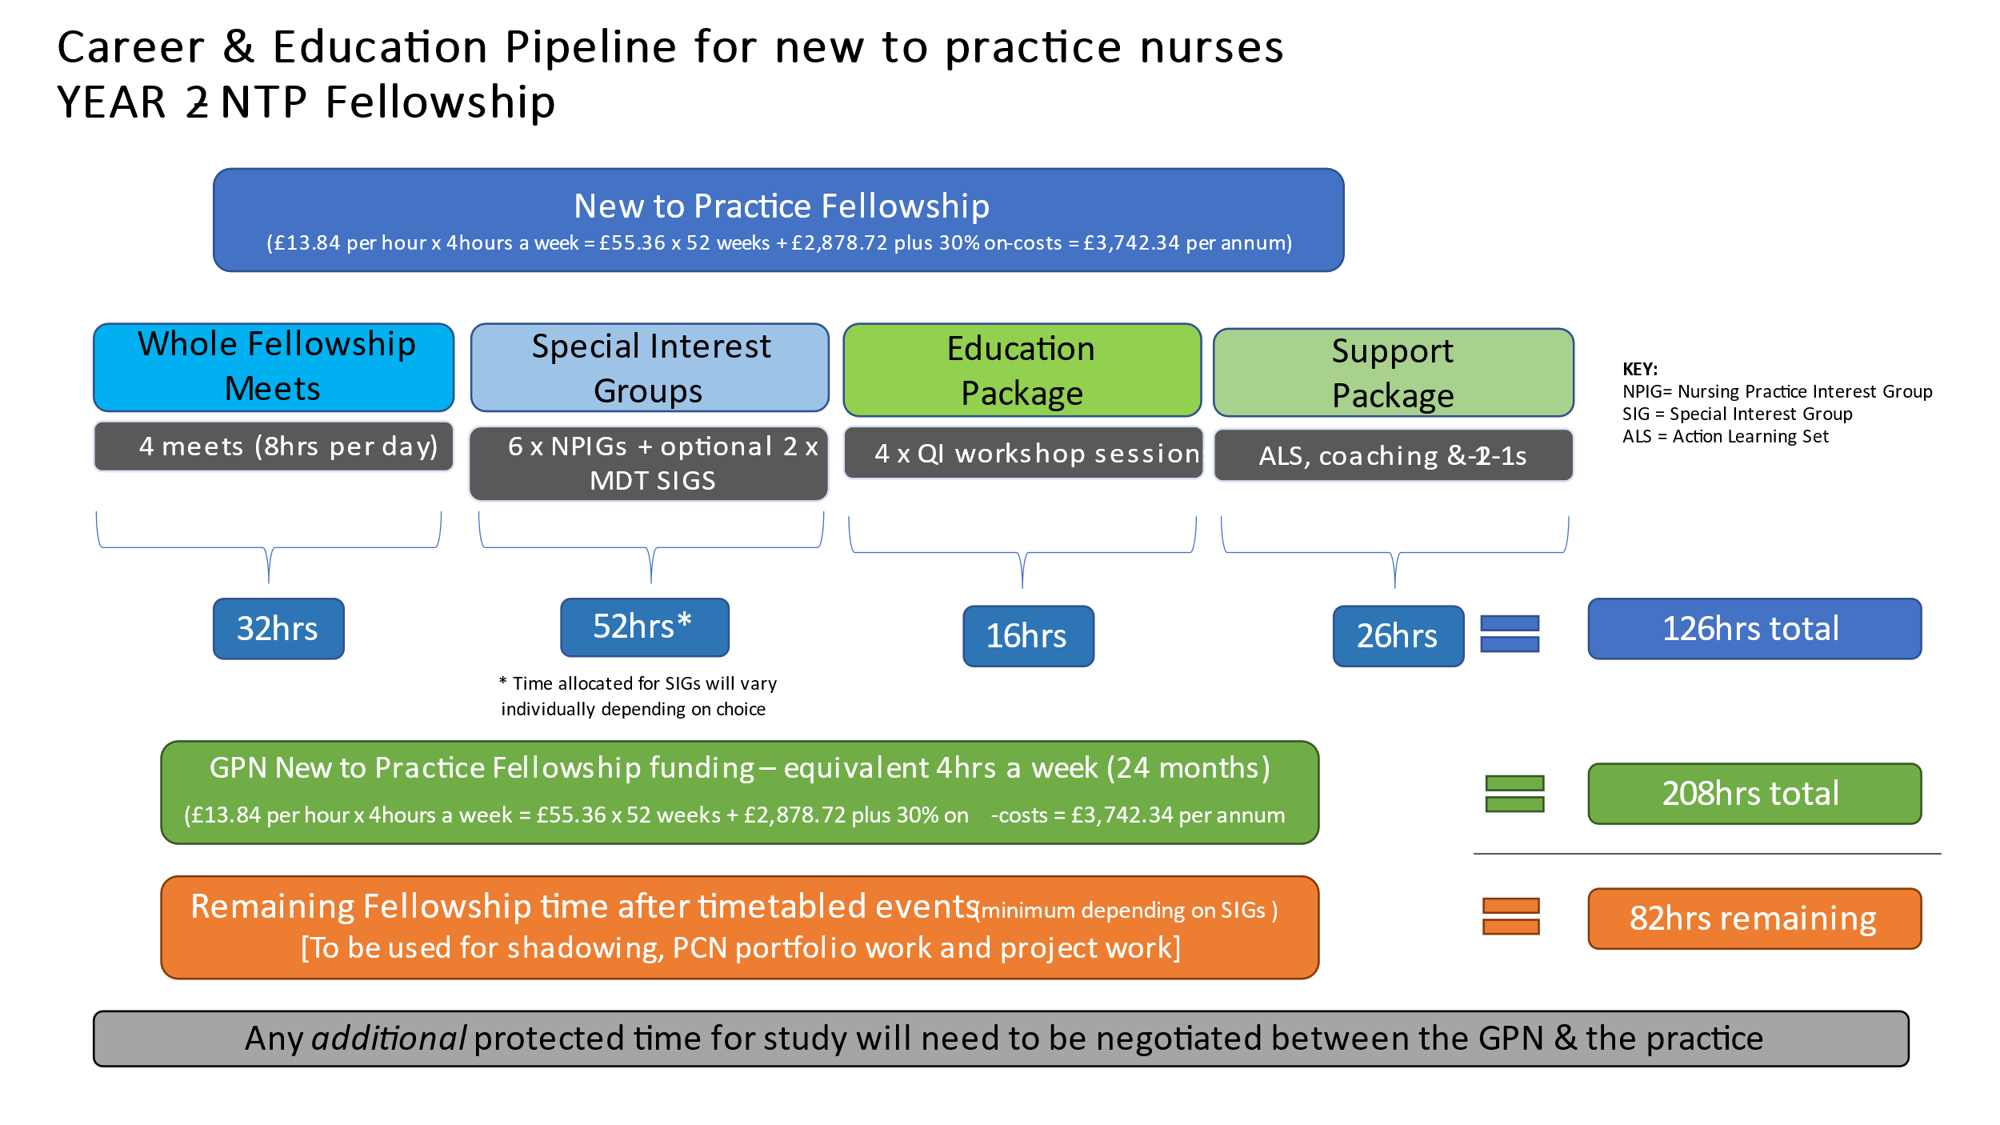

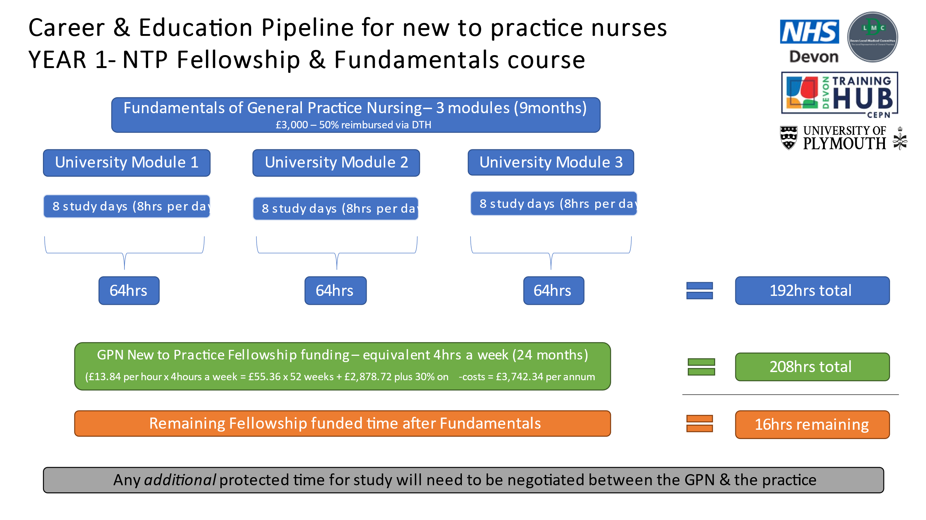

**Special Interest Groups**

These are optional for GPNs but all hold relevance to their role and will involve expert speakers

**Nursing Practice Interest Groups**

These groups are aimed at building on knowledge gained in Year One, through the HEI Fundamentals Programme (UoP). They will alternate between F-2-F and online workshops. Each session will focus on one key area but work through different elements to build on complexity whilst allowing them to be accessible to all nurses on the programme at any stage. There will be six in total.

**NB:** Nurses are also able to join the SIGs if relevant and useful for their practice. This may also be dependent on their NTPF 2nd year focus.

**Partnership Preparation Programme**

This programme is open to GPNs but it is acknowledged that it may not be appropriate for all GPNs coming new into General Practice, depending on their previous career and nursing experience. This would be discussed with the individual at 1-2-1s prior to enrolment.

* 10 part webinar series of sessions lasting 60-90 minutes from 1300-1430 on Wednesday lunchtimes
* 15 mins delivery at start followed by facilitated small groups then coming together at the end

**Module 1: Partnership Finances**

|  |  |
| --- | --- |
|  | **Proposed date** |
| 1A: Understanding balance and income statements | 10/5/23 |
| 1B: Understanding the key financial ratios | 24/5/23 |
| 1C: Generating revenue | 14/6/23 |
| 1D: Partnership liability | 21/6/23 |

**Module 2: Key Legal Frameworks and Contracts**

|  |  |
| --- | --- |
|  | **Proposed date** |
| 2A: Understanding partnership agreements | 6/9/23 |
| 2B: Understanding GP-NHS contracts | 13/9/23 |
| 2C: Introduction to employment law | 27/9/23 |

**Module 3: Communication Strategies and Skills for Partnership**

|  |  |
| --- | --- |
|  | **Proposed date** |
| 3A: Getting the most out of partnership meetings (influencing and negotiating) | 1/11/23 |
| 3B: Dealing with difficult situations (handling conflict, dealing with staff) | 15/11/23 |
| 3C: Interview skills | 22/11/23 |